Name: Archana Devi.P
Reg Number: 192521192
Course: Programming in Java
Code: CSA0923
Github Link: https://github.com/Archix17/CSA0923-JAVA
ASSIGNMENT 5

PART A – Written concepts and implementation
A1 – File I/O: Bus Pass Records
A1.1 Aim
To develop a Java application that reads bus pass records from a CSV file, validates the records and searches for a particular bus pass using its pass ID.
A1.2 Theory
Java provides file handling classes through the java.io and java.nio.file packages.
Important classes:
Class | Purpose
FileReader | Reads character data from a file
BufferedReader | Reads text efficiently using a buffer
FileWriter | Writes character data
BufferedWriter | Writes text efficiently
Files | Provides file operations
Path | Represents a file path

A CSV file stores data in comma-separated format.
Example – bus_pass.csv
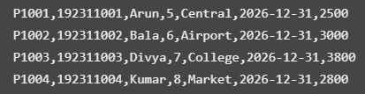
Each record contains seven fields:
- Pass ID
- Register number
- Student name
- Route number
- Boarding stop
- Validity date
- Amount
A1.3 Algorithm
- Start the program.
- Open the CSV file using BufferedReader.
- Read each line from the file.
- Split the line into fields.
- Check whether the record contains seven fields.
- Validate the route number and amount.
- Display valid records.
- Search for the required pass ID.
- Display the matching record or a not-found message.
- Close the file.

A1.4 Java implementation
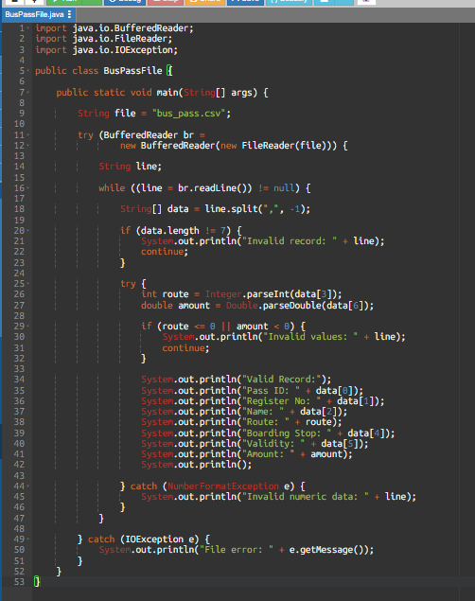
A1.5 Complexity analysis
Let n represent the number of records in the file.
- Time complexity: O(n) – every record is read once.
- Space complexity: O(1) auxiliary space – only one record is processed at a time, excluding the current line's storage.
A1.6 Result
The Java application successfully reads the CSV file, validates the bus pass records and displays valid records while rejecting invalid data.
A2 – Buffered vs Unbuffered File Reading
A2.1 Aim
To compare the performance of buffered and unbuffered file reading in Java and identify how buffering improves file-reading efficiency.

A2.2 Theory
- Unbuffered reading: Reads data directly through the input stream. Reading one byte at a time can involve frequent read operations.
- Buffered reading: Stores a block of data in memory and supplies data from the buffer, reducing frequent underlying read operations.
Important classes:
- FileInputStream
- BufferedInputStream
A2.3 Difference
Unbuffered reading | Buffered reading
Uses FileInputStream | Uses BufferedInputStream
Reads directly from the stream | Uses an internal buffer
One-byte reads can be slower | Usually faster for repeated small reads
More frequent underlying read operations | Fewer underlying read operations

A2.4 Algorithm
- Create a test file.
- Read the file using FileInputStream.
- Record the execution time.
- Read the same file using BufferedInputStream.
- Record the execution time.
- Compare the results.
- Identify the faster method.

A2.5 Java implementation
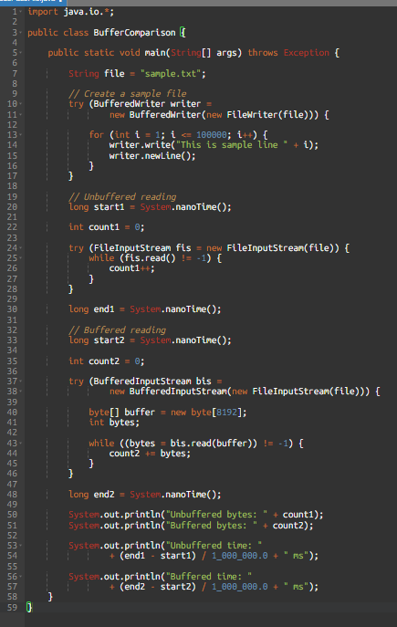
A2.6 Observation table
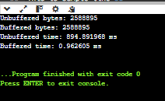

A2.7 Complexity analysis
- Both methods have O(n) time complexity because every byte is read once.
- Buffered reading generally improves practical performance by reducing the number of underlying read operations.
- Its buffer requires O(b) extra memory, where b is the buffer size.
A2.8 Result
Buffered file reading generally provides better performance than reading one byte at a time using an unbuffered stream.
A3 – DAO Pattern and Database Access
A3.1 Aim
To implement the Data Access Object (DAO) design pattern in Java to separate database operations from business logic.
A3.2 Theory
- DAO stands for Data Access Object.
- It is a design pattern used to separate database-related code from the main application.
Main components:
- Model class – stores data.
- DAO interface – defines database operations.
- DAO implementation – performs database operations.
- Main class – interacts with the DAO.
A3.3 Architecture
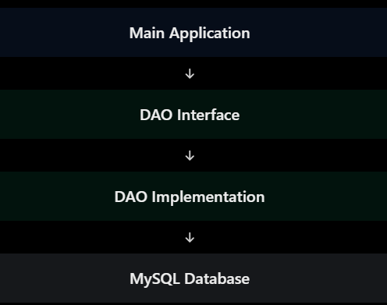
A3.4 Java implementation
Create these three Java files.
1. Student.java
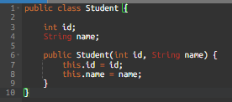
2. StudentDAO.java
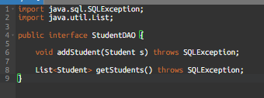
3. StudentDAOImpl.java
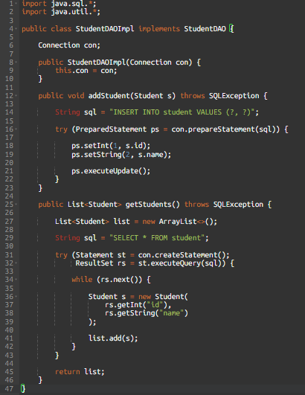
4. DAOMain.java
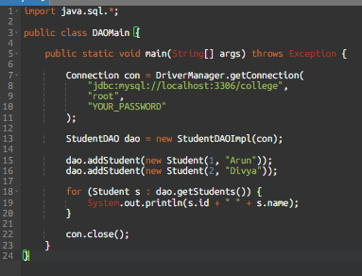
SQL table
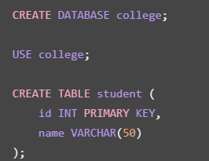
A3.5 Complexity analysis
- Insert: depends on database indexing and query execution; a primary-key indexed insertion is typically approximately O(log n) for the index.
- Retrieve all: O(n) to read and process n returned records.
- DAO pattern: improves maintainability and separation of concerns; it does not automatically improve algorithmic complexity.
A3.6 Result
The DAO pattern successfully separates database operations from the application logic and makes the program easier to maintain.

A4 – Object Serialization and Versioning
A4.1 Aim
To implement object serialization and deserialization in Java and understand how class version changes affect serialized objects.
A4.2 Theory
- Serialization is the process of converting an object into a byte stream.
- Deserialization is the process of restoring an object from a byte stream.
Important classes:
- Serializable
- ObjectOutputStream
- ObjectInputStream
The transient keyword prevents a field from being serialized.
A4.3 Java implementation
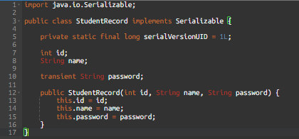
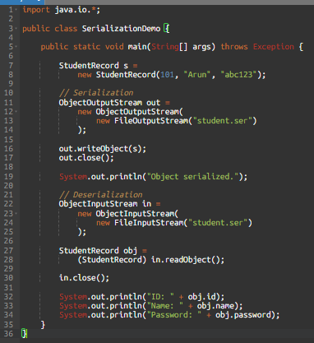
A4.4 Expected output
Object serialized.
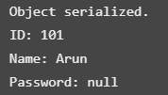
The password becomes null because it is declared transient.
A4.5 Versioning explanation
serialVersionUID identifies the version of a serializable class.
- If compatible fields are added while retaining the same UID, missing fields in older streams generally receive default values.
- If the UID changes, deserialization can fail with InvalidClassException.
- If an object contains a referenced non-serializable object, serialization can fail with NotSerializableException, unless that reference is transient or otherwise handled.
Security note: A real application should not store plain-text passwords in serialized objects. Store a securely salted password hash in a database instead.
A4.6 Complexity analysis
Serialization and deserialization are generally O(n), where n is the amount of data in the object graph being processed.
A4.7 Result
The program successfully serializes and deserializes a Java object and demonstrates how the transient keyword affects stored fields.
A5 – JDBC Transactions and SQL Injection
A5.1 Aim
To implement JDBC transactions and demonstrate how PreparedStatement helps prevent SQL injection attacks.
A5.2 Theory
JDBC stands for Java Database Connectivity. It allows Java programs to connect to relational databases.
A transaction is a group of database operations treated as one logical unit.
ACID properties:
- Atomicity – all operations succeed or none are applied.
- Consistency – database rules remain valid.
- Isolation – concurrent transactions are controlled.
- Durability – committed changes remain saved.
SQL injection happens when untrusted input is directly joined into an SQL query.
A5.3 SQL table
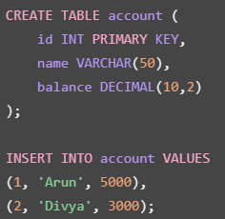
A5.4 Java implementation – Transaction
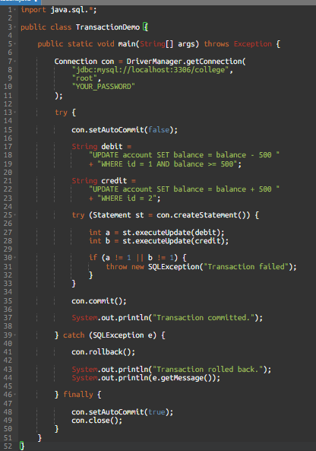
A5.5 SQL injection explanation
Unsafe query:
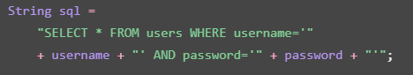
An attacker could enter:
The resulting query may bypass the intended authentication check.
Secure alternative:
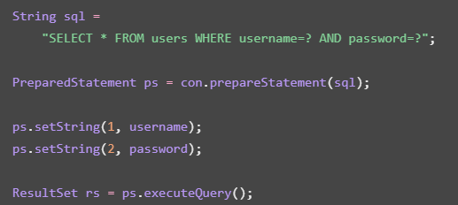
- The parameters are treated as data rather than SQL syntax.
- For real authentication, compare securely hashed passwords rather than storing or querying plain-text passwords.
A5.6 Result
JDBC transactions provide reliable database updates, while PreparedStatement helps prevent SQL injection by separating SQL commands from user input.
-------------------------------------------------------------------------------------------------------------
PART B – Practical experiments and analysis
The Part B tasks require actual experiments, measurements and evidence. We will use separate Java programs for each task.
B1 – File Performance and Data Validation
B1.1 Aim
To measure file-reading performance, compare different reading methods, test the effect of file size and analyse the time required to search for records.
B1.2 Experiment 1 – Buffered vs unbuffered reading
- Use the BufferComparison.java program from A2.
- Run it and record the actual execution time.
B1.3 Experiment 2 – File size comparison
B1.4 and B1.5 Experiment 3 – Search complexity AND Observation
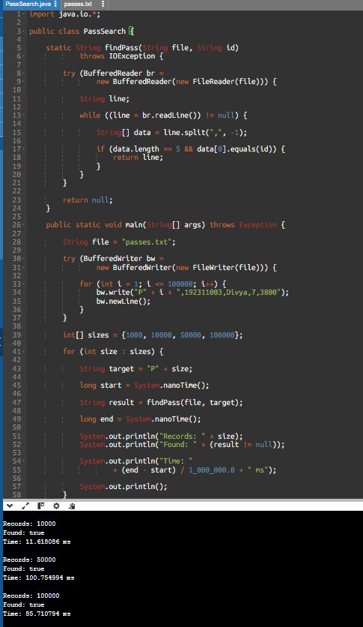
B1.6 Complexity analysis
Searching for a record in a sequential file requires checking records one by one.
- Best case: O(1), if the first record matches.
- Worst case: O(n), if the record is last or not present.
- Average case: O(n).
B1.7 Conclusion
Buffered reading improves practical file-reading performance, and sequential search becomes more expensive as the number of records increases.
B2 – Adversarial Input and SQL Injection Testing
B2.1 Aim
To test the application using invalid or malicious input and verify that file validation and prepared SQL statements protect the system.
B2.2 Test cases – File validation
Using this test data:
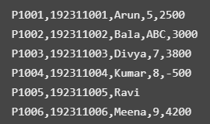
The simplified five-field format is used here for the search experiment.
Test case | Input | Expected result
1 | Valid record | Accepted
2 | Nonnumeric route | Rejected
3 | Negative amount | Rejected
4 | Missing fields | Rejected
5 | Valid final record | Accepted
6 | Empty line | Rejected or skipped

B2.3 Complete PassStore implementation
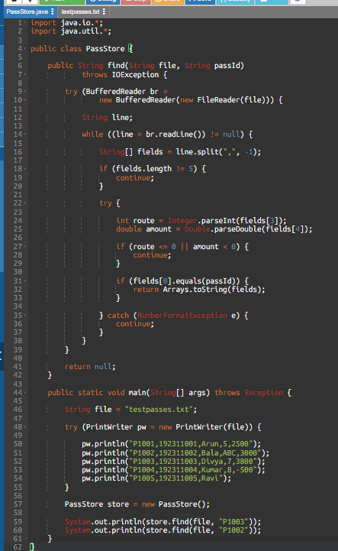
B2.4 Expected output
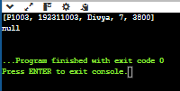
B2.5 SQL injection testing
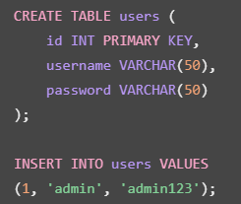
Using this input in your security experiment:
Compare the following:
- A query created by concatenating input using Statement.
- A query using PreparedStatement with parameters.
Expected observation:
Method | Expected behaviour
Statement with concatenation | Vulnerable to SQL injection
PreparedStatement | Treats the input as parameter data

For a real application, use password hashing and do not use plain-text passwords.
B2.6 Result
Invalid records are rejected, valid records are retrieved, and PreparedStatement prevents user input from changing the intended SQL query structure.
B3 – JDBC Performance and Transaction Testing
B3.1 Aim
To compare Statement, PreparedStatement and batch insertion methods and study the performance of database transactions.
B3.2 Database setup
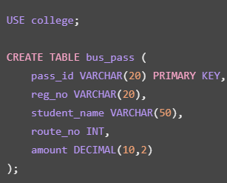
B3.3 JDBC insertion comparison
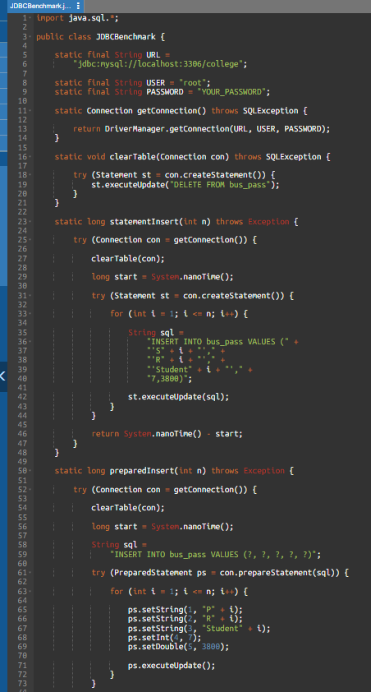
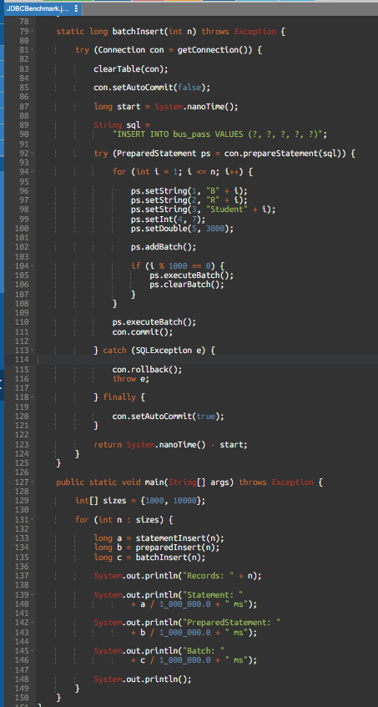
The program tests 1,000 and 10,000 records. Run 100,000 only after confirming the smaller tests work. The benchmark is an educational comparison; repeat runs and use averages or medians for a fairer result.
B3.5 Transaction experiment
Run this SQL to check your table:

To demonstrate rollback:
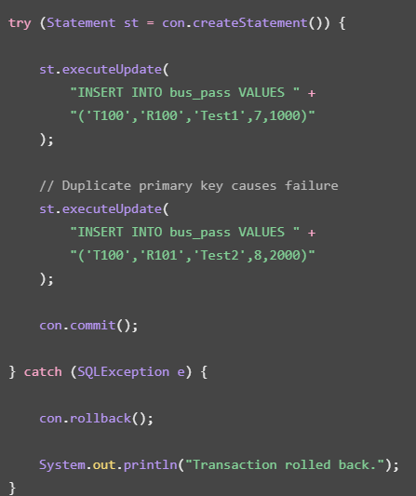
After running the code:
Expected result: no row should be present because the transaction was rolled back.
B3.6 Analysis
- Statement executes SQL strings directly.
- PreparedStatement allows parameterized SQL and reuse of the statement.
- Batch processing groups multiple insert operations and reduces communication overhead.
- Transactions ensure that related database operations succeed or fail together.
B3.7 Result
The experiment demonstrates the performance differences between JDBC insertion techniques and verifies transaction rollback when a database operation fails.
B4 – File-to-Database Migration and Final Evaluation
B4.1 Aim
To migrate bus pass records from a CSV file into a MySQL database, validate the records and evaluate the suitability of file storage and database storage for a large-scale application.
B4.2 Theory
File storage is useful for simple applications and small datasets.
Database storage is suitable for applications that require:
- Concurrent access.
- Data consistency.
- Searching and filtering.
- Transaction support.
- Centralized data management.
- Security and backups.
B4.3 SQL table
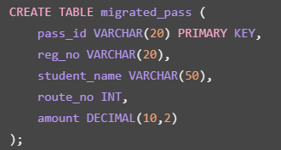
B4.4 Migration Java program
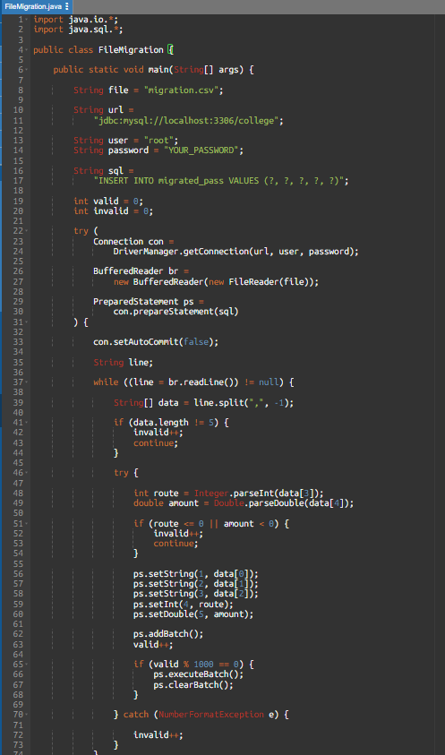
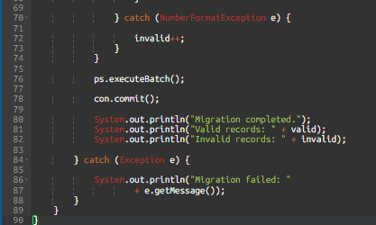
- This example skips invalid records and loads valid ones in batches within a transaction.
- For a production migration, use a separate error log containing each rejected line and its reason, and explicitly roll back on any database failure.
B4.5 Sample migration file
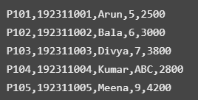
B4.6 Expected output
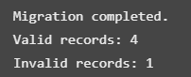
B4.7 Verify database records

B4.8 Database metadata
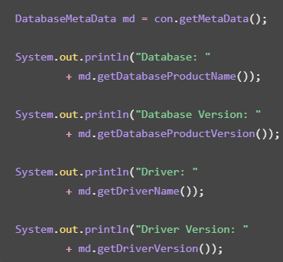
B4.9 File vs database comparison
Feature | File storage | Database
Simple setup | Easy | Requires setup
Searching | Sequential search unless indexed separately | Supports indexes
Concurrent access | Difficult to coordinate | Supports concurrent access
Transactions | Must be implemented separately | Built-in transaction support
Security | File-level permissions | Database access control
Large datasets | Less suitable for complex queries | More suitable
Backup | File backup | Database backup tools

B4.10 Final recommendation
- For a bus pass system used by 12 campuses with potentially 100 times more records and multiple counters accessing the data simultaneously, a centralized relational database is recommended.
- A database provides transaction management, indexing, access control, concurrent access and centralized backup facilities.
- Appropriate indexes should be created on frequently searched fields such as pass_id and route_no.
B4.11 Result
The migration program successfully transfers valid CSV records into MySQL, rejects invalid records and demonstrates why database storage is more suitable for a large-scale bus pass system.

